Erosion Hazard Assessment of Boolcoomatta Reserve
John S. Douglas, Ecologist, BA, MSc.
(University Adel PhD candidate, CEO Apogee Imaging International, former Director SA Centre for Remote Sensing and Head Ecological Survey of SA, Department of Environment).

SUMMARY:
During a stay at Boolcoomata Reserve, where my wife Jin Douglas was teaching the Dermer children, I carried out a brief erosion hazard assessment using satellite and some aerial imagery. The methodology was simple; visual inspection of Google Earth satellite imagery to locate the key areas of gully erosion and assign some general classes to them. Followed by assessment of selected sites using higher resolution aerial imagery. Then field ground-truth was carried on selected sites to confirm the classes. Vertical profiles over erosion sites and creeks (Thalwegs) were generated classes using Google Earth Pro software.
.
IMAGERY INTERPRETATION:
Turner (1990, p. 385) observed that “the linkage of remote sensing and GIS technologies with landscape ecological research, which integrates the spatial pattern of land-cover and ecological processes, can provide a sound basis for assessing broad scale changes in the rural landscape and developing strategies for land management.” The sites were mapped onto Google satellite imagery as polygons representing the general boundaries of those specific sites. No attempt was made to make detailed maps of the specific sites. From the satellite and other source aerial imagery I developed the following general classes:
- Ephemeral creek bed and over-bank erosion in non-consolidated sediment: Red.
  - Severe active headwall gully erosion.
  - Moderate active headwall gully erosion.
  - Early stage gullying
  - Vegetation stabilised gullies
- Gullying in moderate slope and consolidated sediment: Pink
  - Severe
  - Moderate
  - Stable
- Gullying in steep slopes: Blue
- Large scale dendritic erosion, Yellow.
- Piospheres, White
GROUND TRUTHING:
Because of time limitations only a few examples of the above classes were visited and photographed along with basic measurements of depth and observations. This survey provides a basis for follow on surveys by the Reserve Manager. Bush Heritage should engage with high school students of geography and university students of geomorphology, geology and environmental studies, as this reserve contains many examples of classic erosion types.
SITE EXAMPLES and METHODOLOGY.
The following plates and diagrams illustrate the range of gullying within the Boolcoomatta Reserve. Google Earth satellite imagery was used to locate the main areas of gully erosion, along with aerial B&W imagery. Profiles were created using Google Earth Pro imagery using the underlying SRTM digital terrain model from Space Shuttle. Note that although the DTM is course in absolute terms, however in relative terms it is suitable to provide useful surface profiles and thalwegs, including slope gradients as percentages. The alternatives including LIDAR and ground survey, are cost/time prohibitive for surveys like this one. The following images and their profiles illustrate this practical utility of Google Earth Pro. In hydrological and fluvial landforms, the thalweg is a line drawn to join the lowest points along the entire length of a stream bed or valley in its downward slope. These profiles are quick and easy to produce, allowing rapid survey of wide areas and many sites. They are also useful indicators of where gully erosion is likely to be severe, taking into account prior land use, soil structure and catchment size.
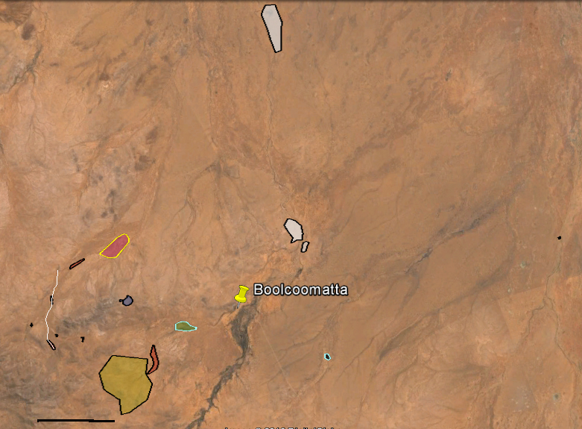
PLATE 1: Overview of sites and creek profile 1. Colours are explained in the classes described under Imagery Interpretation pages 1 and 2.

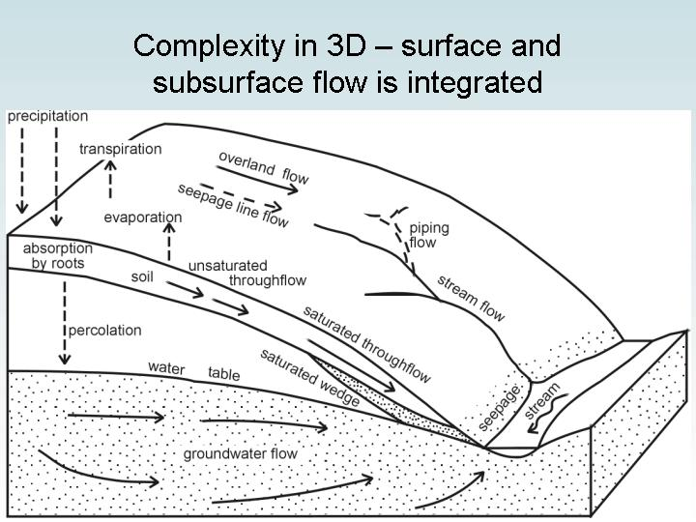
DIAGRAM 1: Block model of regolith and subsurface processes in gullying. (From Dr Colin Pain. AAS Salinity Conference, Canberra, Oct 17 2003).

RESULTS:
The following plates illustrate the different classes visited, emphasis was placed on visiting Class 1 gully types as they represent the most active erosion types and if caught early may be suitable for remedial actions.

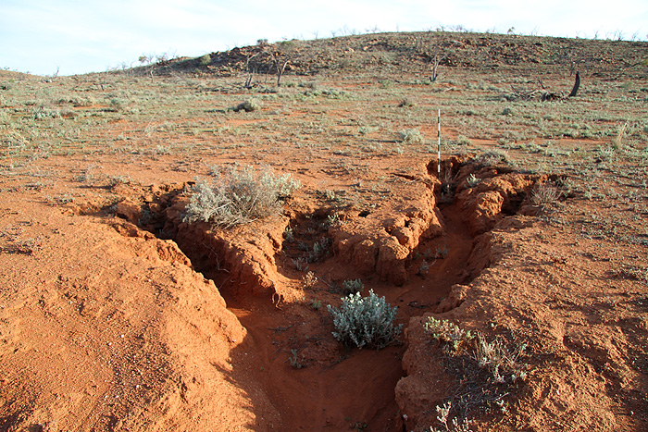 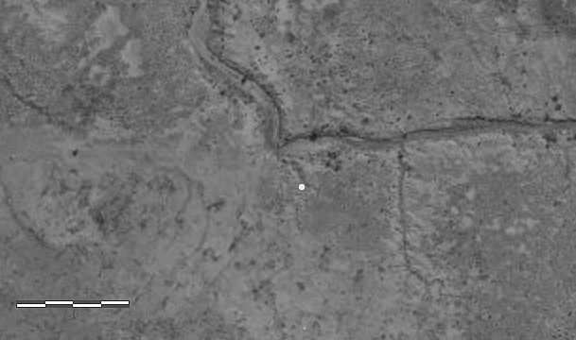 PLATES 2a and 2b: Small active headwall gully (class 1c), at S 31° 26’ 18.14”. E140° 58’ 54.37” Plate 1a is looking south. Plate 1b shows location on an aerial image, scale is 60m. This is a typical early and active stage of headwall gulling in unconsolidated soils overlying a consolidated layer, and migrating up-slope towards the sheet flow source and an adjacent rocky hill.

5km
PLATE 3: SITES 1, 2 and 5 with profiles.
This preliminary survey found six Class 1a and b sites all on the creeks leading to twin dams N.W of Wiperaminga Hills. The following images and data illustrate these sites through imagery, profiles, ground truth and their relationship to each other.
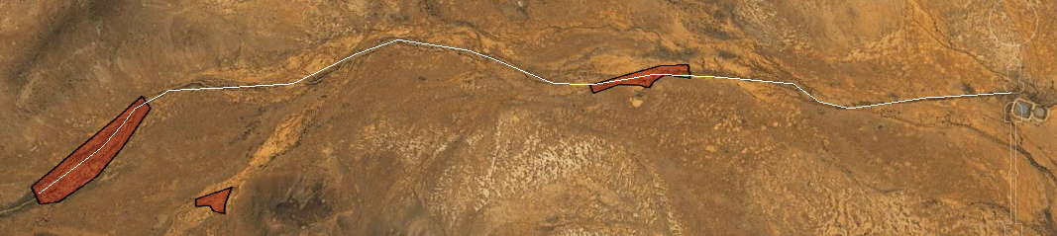
Site 2
Twin dams
Site 5
Site 1
Headwall Gullying Sites 1 and 5 shown on creek profile 1 leading to the twin dams a distance of 5.4 km, site 2 is located on a tributary.

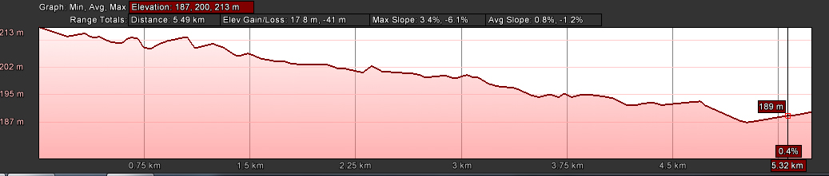
Profile 1: Note the fall over 5.4 km is 26 metres with an average slope of 1.2% and maximum of 6.1%.
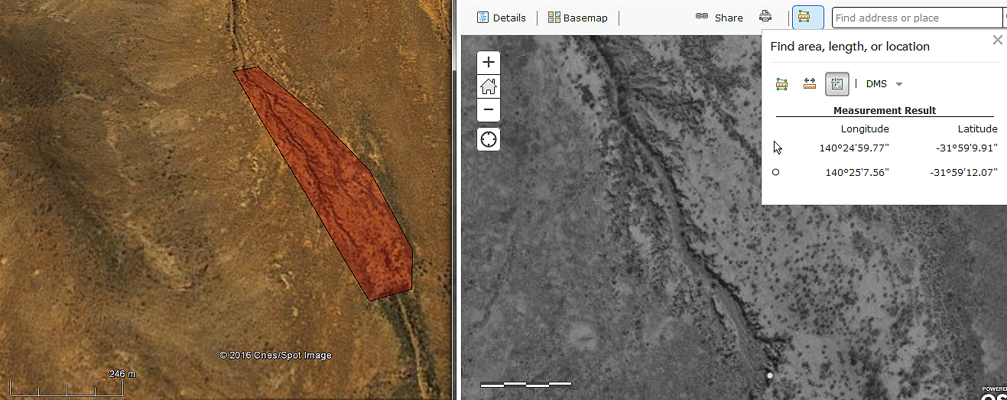
PLATES 4a and 4b: Headwall Gully Site 1. This is the largest headwall gully system on Boolcoomatta with the headwall 50m wide. It is accessible only by foot and is 2.3km from the track to the east over the so-called Saddle”. The gully erosion extends for over 700 metres from the headwall covering 3 hectares and it is a classic example of this geomorphological type. Scale in 3b is 60m.This extensive gully erosion exhibits classic characteristics of a mature and active system migrating both longitudinally and laterally. The system has developed in what appears to be a meandering paleo-stream overbank depositional environment. The deep cuts display a complex depositional history of this creek. They indicate several deposition episodes of previous higher rainfall events and/or periods that deposited significant sand, clay and gravel deposits in a sequence of events, over perhaps several thousand years. The present gully is carved into those older fluvial deposits.
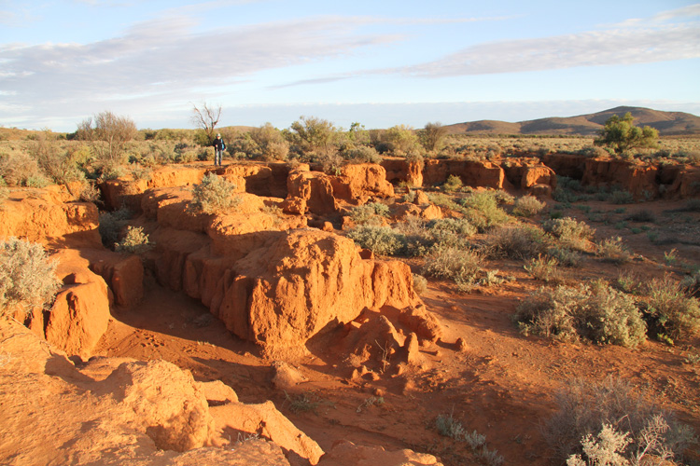
PLATE 5: Site 1 looking 143 degrees SSE to the headwall which is over 2m high, lateral gullying is extensive, indicating
Significant sheet flow from the adjacent overbank flats.

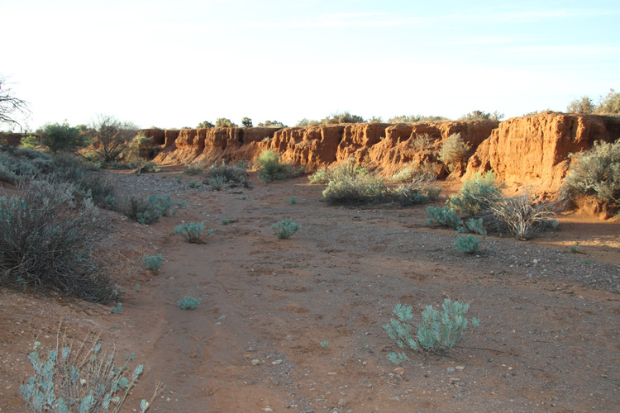
PLATE 6: Main gully bed looking 330 degrees north, the size of the gully indicates significant rain fall events over many decades. This is coupled with an extensive catchment area of at least 8km² with low infiltration, with high runoff rates. The bed is colonised by Mariana sp and Seneca sp, which are not significant as far as stabilization.
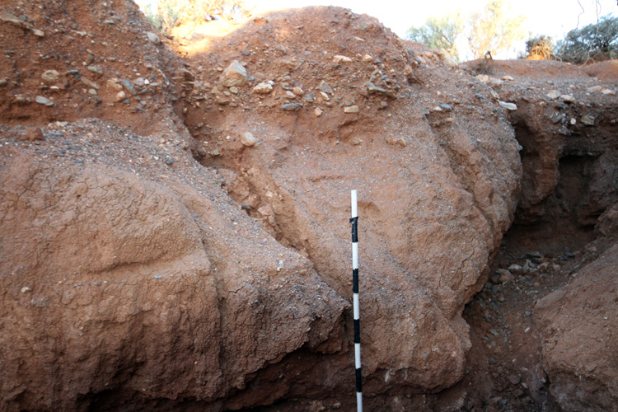
PLATE 7: Gully soil profile 1. This soil profile illustrates the episodic depositional environment of this creek and its flood plain. The top 20cm is course clay/sand followed by a 40cm angular gravel deposit. This deposit indicates a period of active erosion from the adjacent rocky hills and deposition in the present creek/gully area. The gravel beds could be due to a meandering stream depositional environment, as they appear to alternate from side to side. An alternative view is they are due to episodic high rain fall events moving gravel down slope as sheet wash, this needs further study. The angular shapes indicate short transport distances from the source in the local hills. Beneath 60cm there are several other depositional layers indicating a long depositional history.

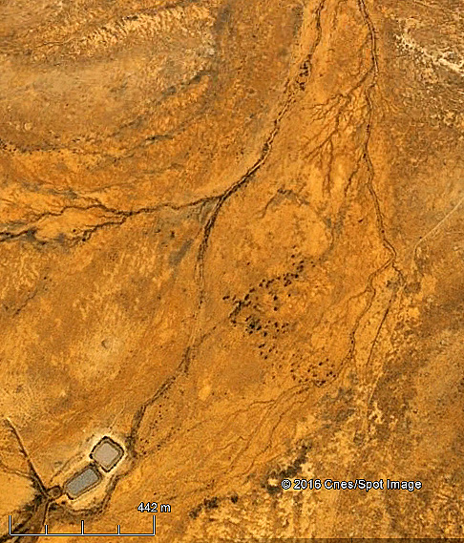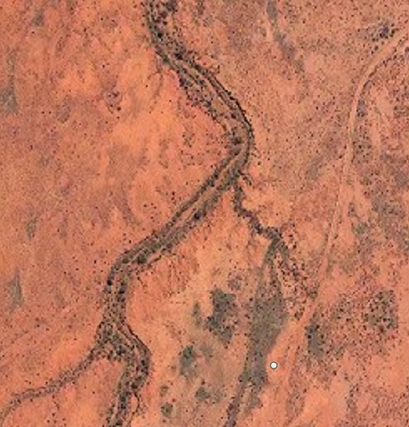
PLATE 8a: Oonarta Dam and creek erosion area PLATE 8b: Creek ground-truth site – (scale 50m)
This site is a class 1d type (vegetated gully) with extensive bare clay pan flats collecting runoff and causing lateral headwall gullying as shown in the following plates.

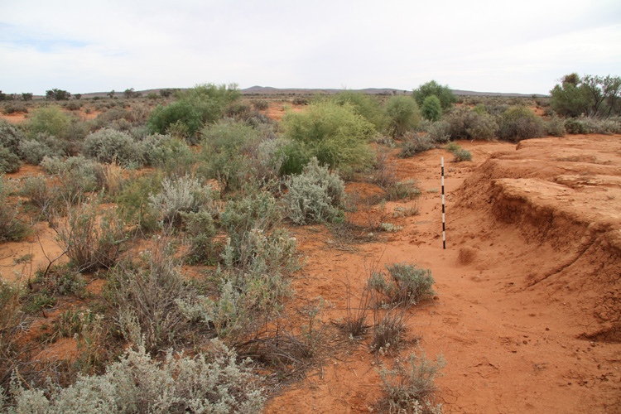
PLATE 9: Oonarta creek looking north showing well vegetated bed and adjacent bare flats with lateral gullying.
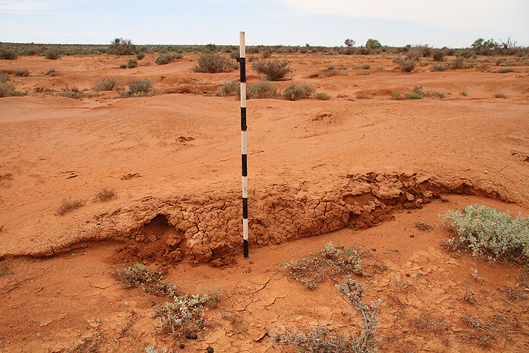
PLATE 10: Actively eroding flats adjacent to the creek, note the soft spongy layer which appears to be salinized and is easily eroded. Recent emu tracks have broken the crust.

PLATE 11: CLASS 2: Broad scale dendritic erosion on moderate slope and consolidated regolith. This class is found next to hills and are wide spread. They appear to be shallow and not very active, perhaps removal of grazing pressure by sheep and goats for a decade has assisted stabilization. These sites require further study.

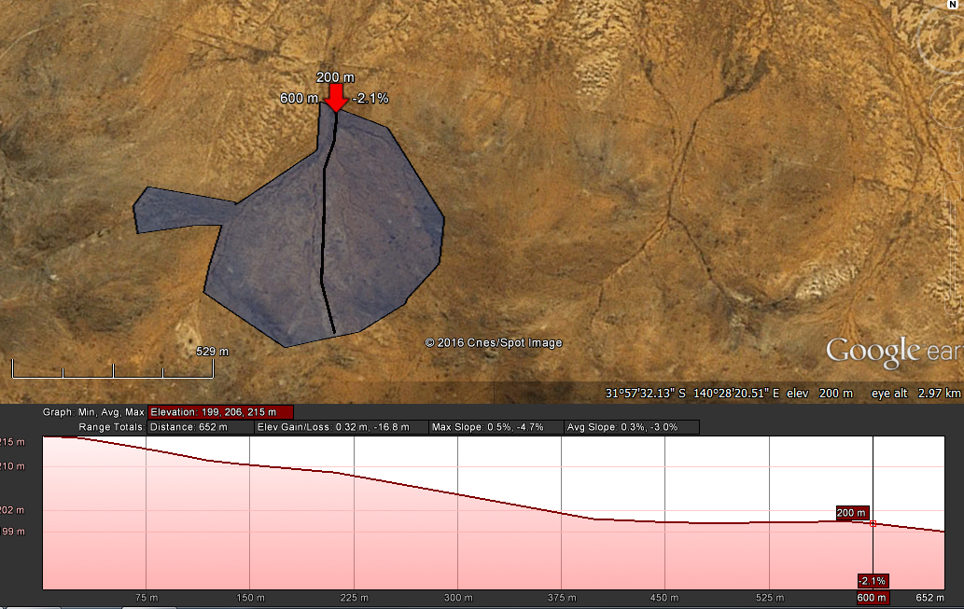
CLASS 3 Gully:

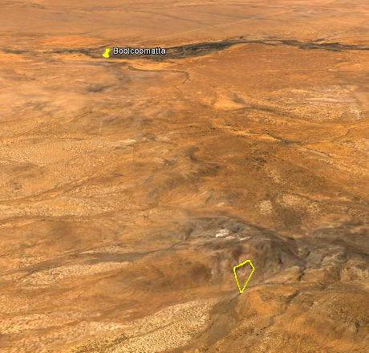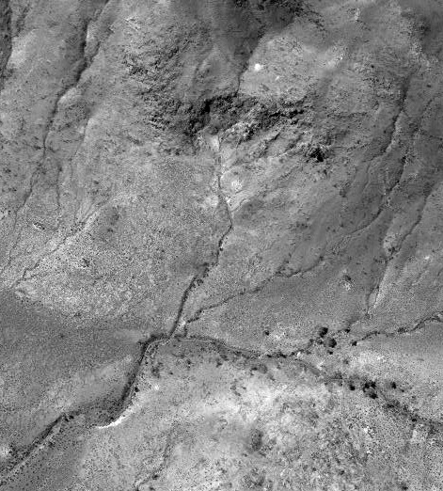
PLATE12a: Class 3 gully location. PLATE 12b: Detailed image of class 3 gully.

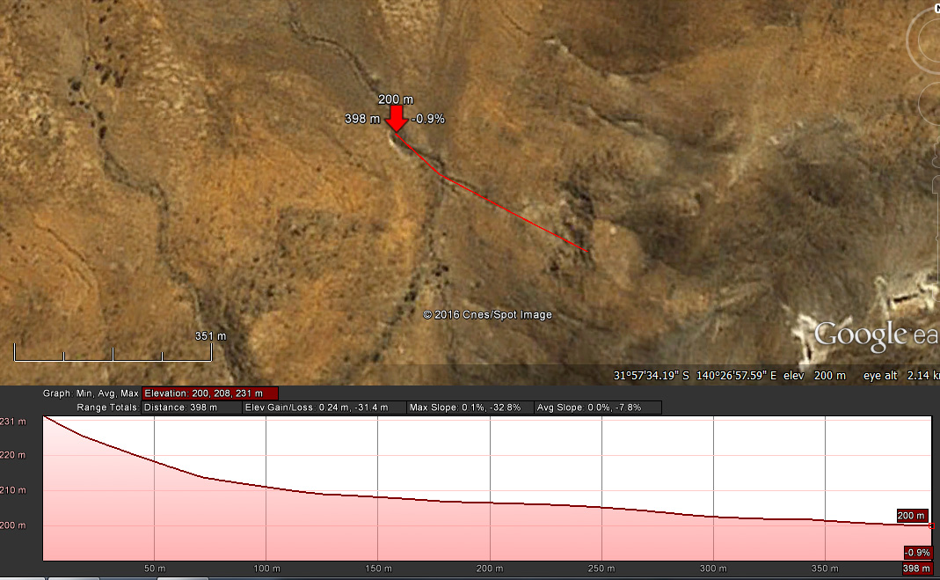
PLATE 11: CLASS 3 gully profile. This demonstrates the high slope angle reaching 33 degrees in the headwall fan in this gully system carved into the hillside.

Class 4 was not visited due to time constraints.

CLASS 5: PIOSPHERES.
The term Piosphere was originally defined as an indicator of the localized impact of grazing on vegetation and soils. It is a radiating zone of attenuating animal impact away from a concentrator, e.g., water, mineral licks, bedding grounds, etc. Over time there may be increased soil erosion, reductions in vegetation cover and changes in soil chemistry within Piospheres. Remote sensing is an ideal way to locate, map and monitor Piospheres over large areas, there are a number of examples on Boolcoomatta which although stock have been excluded for a decade, are still obvious. Sheep walk in to watering points after daily grazing, they tend to “follow the leader” creating radial tracks of compacted soil. The case illustrated here at East Southern dam and its watering point. The radial tracks are distinct and form a half-circle due to a NS fence line to the west of the watering point. Field ground truth revealed that the dark radial lines are where the sheep tracked to the water point. These compacted linear tracks concentrate water and humus and have been colonized by annual herbs such as Atriplex and Sclerolaena species. However between these lines general erosion due to overgrazing is evident. Plates 6a and 6b are of East Station Dam, 6b is looking north to the water point.
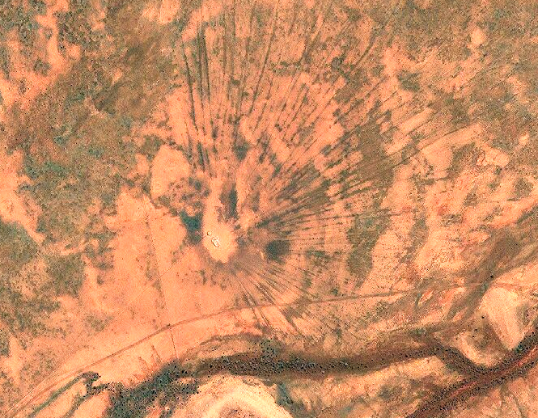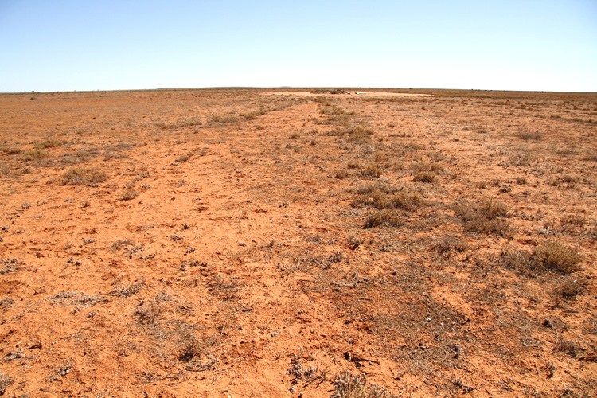
PLATE 6a: Satellite image of watering point Piosphere. PLATE 6b: Ground view of arrow in 6a, arrow is along sheep vegetated track.

DESERT CRUST

So-called “Desert Crust” or Cryptobiotic Crust is a combination of various Lichen types and Cyanobacteria covering the surface of otherwise bare soil. They provide a protective cover helping to lower the impact of wind and water erosion on low relief and flat areas of arid lands including deserts. They are impacted by cloven hooved stock such as sheep and cattle, native fauna are only a minor hazard. Vehicle traffic also causes crust impact and additionally alters the soil structure due to compaction. Stock and vehicle tracks can remain for very long periods in arid lands.

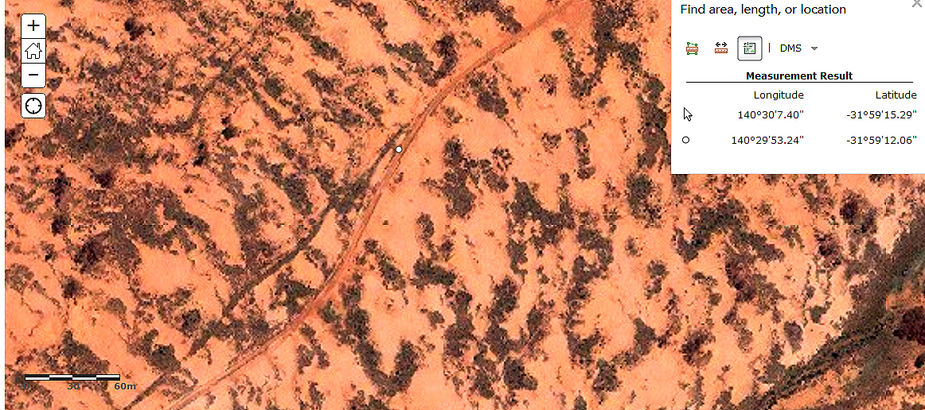
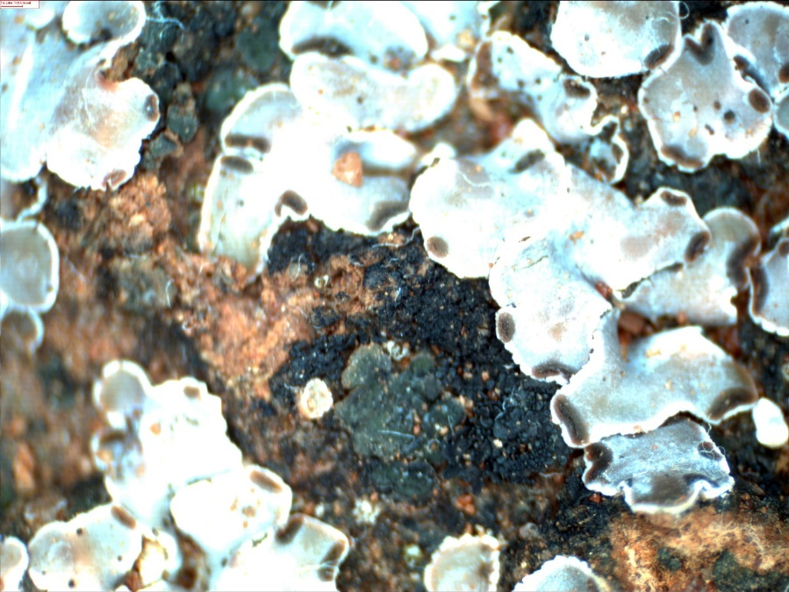
Cyanobacterial crust

Cryptic Lichen
Plate 6: Cryptibiotic crust collected from Noon Flower Track, imaged under a stereo-microscope x30. (Image J S. Douglas).

CONCLUSIONS and RECOMMENDATIONS:

This short survey has revealed a broad range of erosion types in the Boolcoomatta Reserve. Based on satellite and aerial imagery I have grouped these into five logical classes. Classes 1, 2 and 5 had the highest erosion hazard and were visited.

RECOMMENDATIONS:

- Future work should assess classes 3 and 4 as well as a number of mining sites.
- Class 1 gullies should have star pickets placed at least 20m out from headwalls and accurate measurements made as to the headwall as baseline data.
- Photo points should be established.
- Class 1 Gullying should be monitored during and after major storm events to collect data on headwall erosion rates and processes.
- A practical erosion management plan should be developed.
- A student project should be developed to have high school and university students participate in the above.

AKNOWLEDGEMENTS:
I wish to thank the reserve manager Alistair Dermer for coming up with the topic of erosion. My wife Jin for getting me to Boolcoomatta Reserve as she was a volunteer teacher for the three Dermer children over a month period.

